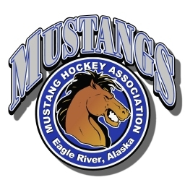
Mustang Hockey Association
Equipment List

It is the responsibility of the parent or guardian to ensure that their child is furnished with, and wears to all games and practices, the following gear. When purchasing new equipment, please be aware that blue, black and white are the preferred colors at MHA.

- Helmet with face mask
- Mouth piece (colored for U12 Division and Up)
- Shin pads and elbow pads
- Shoulder and chest pads
- Hockey gloves
- Hockey pants
- Athletic supporters with hard plastic cup (male)
- Pelvic protector (female)
- Hockey socks and garter belt (or Velcro shorts)
- Jersey (Order through MHA)
- Hockey skates
- Hockey stick (cut to size) and stick tape
- Neck guard
- Gear Bag

Goalkeeper gear (not required for Mini Mites) is provided by MHA as needed. It must be signed out from the Equipment Manager and returned at the end of the season.

Note: All equipment must be HECC certified and in good condition.

